**Investigation on Wear Behaviors of WC and Ti6Al4V Coated AISI 316 L Stainless Steel by ESD Coating Method**

**ABSTRACT:** AISI 316 L austenitic stainless steel has a wide range of applications in various sectors of industry (chemistry, petrochemical industry, paper industry, nuclear engineering, dairy equipment) due to high corrosion resistance at high temperatures. In addition to these superior properties, they are limited in their use due to their low hardness and poor abrasion performance. Therefore, surface modification of materials used in recent years has been on the rise due to the development of technology and the expectation of superior properties over materials. Electrospark deposition (ESD) is a special microbonding process used to coat a base material, known as a substrate, with an electrode, which is a stronger, more durable and more durable topsheet, and is a suitable name for surface modification of stainless steels. In this study, WC and Ti6Al4V coatings were applied to the surface of AISI 316 L stainless steel with ESD Method. As a result of abrasion tests, AISI 316 L stainless steel has been improved with low surface hardness and abrasion resistant coatings. AISI 316 L stainless steel wear resistance is 3-10 times less than the resistance of the coating.

**Keywords:** Electro spark deposition, Wear behavior, Tungten-Carbur, Ti6Al4V

1. **INTRODUCTION**

AISI 316 L stainless steels have a wide variety of uses in various industry sectors including chemistry, petrochemistry, paper industries, and nuclear engineering due to its high corrosion resistance at high temperatures. Furthermore, due to its biocompatibility and high corrosion resistance, it has been used in medicine as an implant material (Kayali et al., 2013; Gil et al., 2006; Heras et al., 2008; Nosei et al., 2008; Çelik et al., 2007). Despite such superior properties, its uses have been limited because it has a low hardness and weak wear performance (Kayali et al., 2013; Heras et al., 2008; Çelik et al., 2007). In order to remove these limitations, many studies have been conducted with the aim of improving the surface hardness of AISI 316L stainless steel as well as its corrosion and wear behaviors. These studies include Ti coating via the physical vapor deposition (PVD) method (Heras et al., 2008; Chenglong et al., 2005), diamond-like carbon (DLC) coating (Azzi et al., 2009), Cr2B spray-coating (Jordan et al., 2005), hard Cr coating (Fedrizzi et al., 2002), sol-gel (Chenglong et al., 2005), plasma nitriding (Gil et al., 2006; Çelik et al., 2007), boriding (Kayali et al., 2013), and thin, hard coatings using several plasma-based surface technologies( Dearnley and Smith, 2004).

Coatings are normally used to improve the corrosion and wear properties of metals. There are numerous coating methods, e.g. galvanizing, electrode position, electroless plating, metal spraying, physical vapor deposition (PVD), chemical vapor deposition (CVD), etc., that provide coatings that protect metals in aggressive mediums (Kayali et al., 2013; Heras et al., 2008; Kariofillis, et al., 2006). Electrospark deposition is a micro welding process that uses short duration electrical pulses to deposit electrode materials onto conductive substrates. ESD is increasingly used to repair damaged high value precision products or modify their surfaces for specific properties (Korkmaz, 2015). ESD has broad range of application in aerospace, defense, automotive, and medical industries (Jiao, 2016).

In this study, the effect of WC and Ti6Al4V coatings deposited by ESD techniques on surgical AISI316 L stainless steel is investigated and evaluated for wear behavior in dry medium. The wear properties of coated and non-coated AISI 316 L stainless steels were also studied for comparison.

1. **MATERIALS AND METHODS**

**2.1 Materials**

The chemical analysis of AISI 316 L austenitic stainless steel specimens with a dimension of 15 mm x 15 mm used in experimental study is given in Table 1 and a microstructural image in as received condition is given in Figure 1.

**Table 1.** Chemical composition of AISI 316L austenitic stainless steel used in experimental work

|  |  |  |  |  |  |  |  |  |  |  |
| --- | --- | --- | --- | --- | --- | --- | --- | --- | --- | --- |
| **C** | **Cr** | **Ni** | **Si** | **Mn** | **Mo** | **S** | **P** | **Cu** | **N** | **Ti** |
| 0.02 | 16.89 | 10.62 | 0.39 | 1.5 | 2.11 | 0.03 | 0.033 | 0.34 | 0.054 | 0.008 |

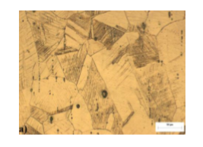

**Figure 1.** Optical Microstructure (x100) of AISI 316 L austenitic stainless steel in as received condition

**2.2 Electro Spark Deposition**

The images of the ESD coating setup prepared for the rotation of the substrate material and the coating machine, the passage of the current for the coating process is eased by using are given in Fig.2. This process was carried out for 230 rpm, 6 x 170 Hz with 90-volts parameter range. Here, argon gas is purged onto the metal surface to improve the surface smoothness and the ESD coating is carried out for 2 minutes.

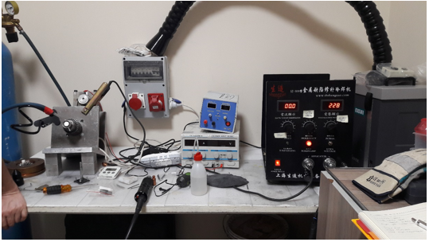

**Figure 2.** Coating machine and coating experiment setup

During the coating process, the copper base was rotated at a certain speed, and the vibrating electrode was contacted with the applicator on the electrode to provide a spark jump. Figure 3 shows a schematic representation of the coatings to be formed on the surface of AISI 316 L stainless steel.

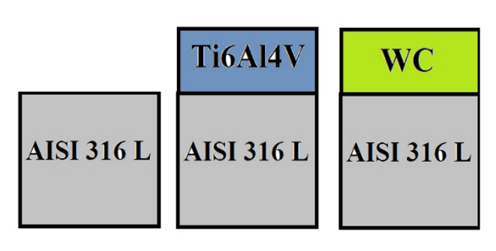

**Figure 3.** Schematic presentation of coatings

**2.3 Metallographic study**

The pieces prepared for the metallographic investigations were cut through and then passed through 120, 240, 320, 400, 600, 800, 1000 and 1200 abrasives respectively and polished with 3 micrometer diamond paste. The polished surfaces were polished with a stainless steel grinder (1 part HNO3, 1 part HCl, 1 part pure water) to reveal microstructures. Microstructures were examined and photographed with an Olympus BX-60 optical microscope and LEO 1430 VP SEM microscope. The layer thicknesses were again measured with the aid of an optical micrometer attached to the same optical microscope. The layer thickness was determined by taking averages of at least fifteen measurements made from the surface of the metallographic sample.

X-ray diffraction analysis was performed for the characterization of the coating layer formed on the surface by the ESD coating method. X-ray diffraction analyzes of the samples were carried out with Shimadzu XRD-6000 X-ray diffractometer using CuKα (λ = 1.5406 °A) radiation between 20-100 degrees.

Hardness measurements of the coatings formed on the surfaces of the samples were made using a Vickers tip under a load of 50 gr from the surface with SHIMADZU HMV-2 model hardness device. Averages were calculated by taking 10 measurements from the surface of the coated samples.

**2.4 Wear test**

The abrasion tests were carried out using the ball-on-disk method in the abrasion device according to ASTM G-77 standard. WC-Co based 8 mm diameter balls were used in the experiments. Wear tests were carried out at dry medium and a room temperature for total distance of 250 m at a slip rate of 0.2 m / s at 330 rpm using a 8 mm track radius under 5 N load. Using separate WC-Co balls for each test, faults that could be caused by surface damage were removed. Prior to the abrasion test, each specimen and WC-Co ball was cleaned with a alcohol. The coefficient of friction is obtained from the friction force, which is recorded in relation to the slip distance. Wear patterns, wear areas and depths obtained as a result of wear tests were determined with Rugosimeter brand roughness device (Figure 4). As a result of the wear tests, the friction coefficient, wear rate graphs are plotted depending on the coating conditions.



**Figure 4.** Wear profile of uncoated AISI 316 L austenitic stainless steel in dry environment

1. **RESULTS AND DISCUSSION**

**3.1 Microstructural analysis**

SEM images of the AISI 316L alloy coated with ESD method are shown in Fig.5. In the case of WC, Ti6Al4V coatings, cracks and delamination occurred with high hardness, resulting in horizontal discontinuity, and cracks were found in Fig.5a, indicating vertical thermal expansion difference. Particularly, in the SEM image shown in Fig. 5b, it is considered that cracks occur during cutting, as well as stress cracks due to the fact that Ti6Al4V coating material is generally suitable for intermetallic formation.

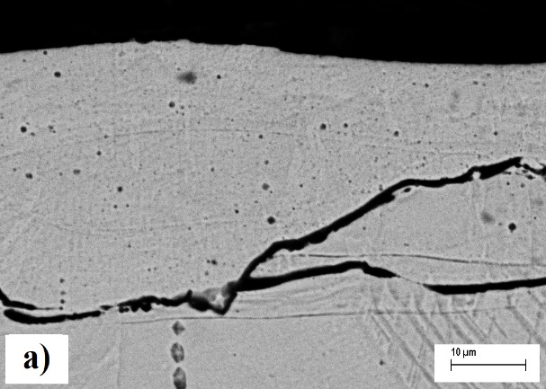 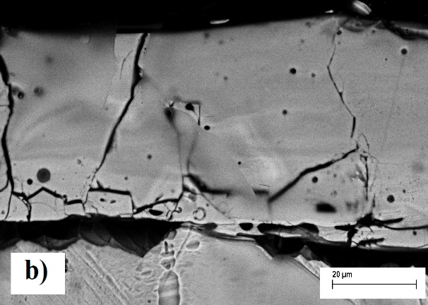

**Figure 5.** SEM images of a) WC and b) Ti6Al4V coated AISI 316 L austenitic stainless steel by ESD method

**3.2 X-Ray analysis**

In the XRD results given in Figure 6a, it is considered that only WC coatings resulted in a larger number of additional phases than Ni + WC coatings, and that the intermetallic phases appeared with an increase in the W free C WC together with Ni in the stainless steel. Figure 6b shows the XRD results of the Ti6Al4V coating. Due to the large number of components, the number of alloy systems has increased. It is observed that the most dominant phases belong to the Fe-Al-Ti alloy system which is followed by FeAl and NiAl systems that are intermetallic in nature, after Fe-Al-Ti phase system.

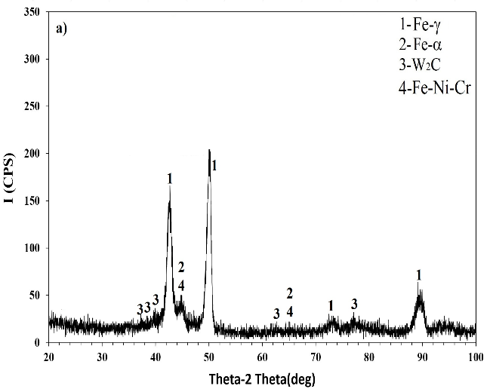 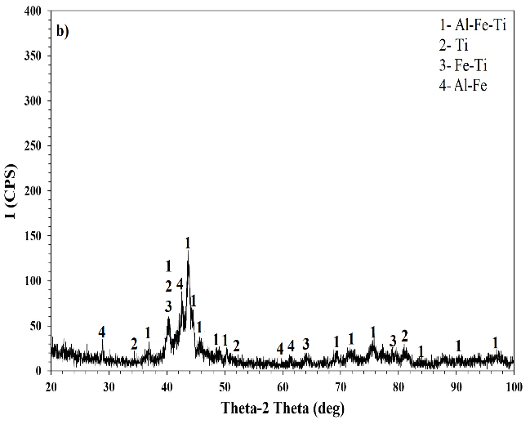

**Figure 6.** ESD method a) WC b) X-ray analysis of Ti6Al4V Coated AISI 316 L austenitic stainless steel

**3.3 Coating layer thickness and microhardness**

In the optical microscope examinations after the coating process by the ESD coating method, it is seen that almost all the samples of the coating layer have a homogeneous thickness. AISI 316 L stainless steel surface was coated with different materials by ESD coating method and the layer thickness obtained was 31.79-47.53 μm, so microhardness measurements were made under 50 gr load. The surface hardness values of the AISI 316 L stainless steel covering layer and the uncoated steel are given in Table 2. The hardness of the coating layer was found between 422 HV0.05 and 978 HV0.05. However, the hardness of the main material is 232 HV0.05. It has been found that the surface hardness of the materials is increased by plating process (except Nickel coating).

**Table 2.** Layer Thickness and Microhardness Values

|  |  |  |
| --- | --- | --- |
| **Coating Conditions** | **Coating thickness (μm)** | **Microhardness values (HV0.05)** |
| AISI 316 L | - | 232 |
| WC coated | 31.79 | 978 |
| Ti6Al4V coated | 47.53 | 422 |

**3.4 Wear test**

Depending on the coating conditions of the AISI 316 L austenitic stainless steel coated in Fig. 7 and Table 3, the friction coefficient and wear rate change of the abraded samples are shown in the dry environment. The lowest coefficient of friction is found in WC coated specimens and the highest coefficient of friction is determined in uncoated AISI 316 L austenitic stainless steel specimen. It was determined that the coefficient of friction of the coated specimen varied from 0.59 to 0.68 while the coefficient of friction of the uncoated specimen was 0.76.  
When the wear rates obtained from the wear tests were examined, the wear rates varied from 68,186x10-6 mm3 / Nm to 604,508x10-6 mm3 / Nm. With coating processes, a reduction in wear rate was detected. Wear resistance of coated specimens was very high compared to uncoated specimens.

**Table 3**. Results from wear tests

|  |  |  |
| --- | --- | --- |
| **Substrate** | **AISI 316 L** | |
| **Coating conds.** | **Friction coefficient (μ)** | **Wear rate 10-6 (Nm/mm2)** |
| Not coating | 0,76 | 604,508 |
| WC coated | 0,59 | 68,186 |
| Ti6Al4V coated | 0,68 | 268 |

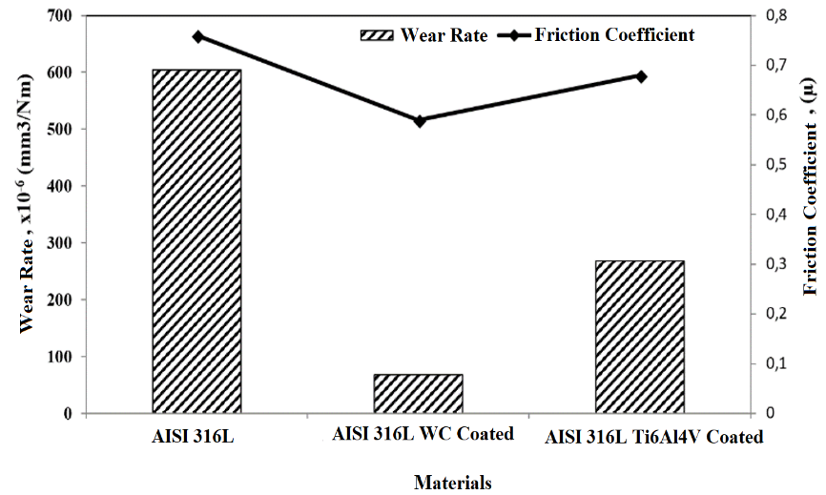

**Figure 7.** Wear speed and friction coefficient diagram of AISI 316 L stainless steel with different coatings by ESD method

**Table 4.** Wear depth and profile results

|  |  |  |  |
| --- | --- | --- | --- |
| **Coating Conds.** | **Coating thickness**  **(μm)** | **Wear depth**  **(μm)** | **Wear area**  **(μm2)** |
| **AISI 316 L** | - |  | 30081 |
| **WC coated AISI 316 L** | 31,59 |  | 3393 |
| **Ti6Al4V coated AISI 316 L** | 47,53 |  | 13336 |

Table 4 gives the wear depth, wear area and layer thickness values of AISI 316 L austenitic stainless steel, which has been untreated and coated with different materials. According to the hardness of the coating layer, decreases in wear depths and field values were found. The highest wear trace depth was found on the uncoated sample, the lowest wear trace depth was found on the WC coated specimens. As a result of the abrasion tests of the coated samples, it was found that the wear of the coated layer was maintained in the coating layer according to the coating layer thicknesses. As a result of the wear tests of the untreated samples, the wear depth reached 35.3 μm.

1. **CONCLUSION**

The results obtained on the AISI 316 L stainless steel surface as a result of coating of different materials by ESD method are given below.

* WC, Ti6Al4V successfully formed on the surface of AISI 316 L stainless steel with ESD method. Phases such as Fe-γ, Fe-α, W2C, Fe-Cr-Ni, Fe-Ti, Al-Ti and Fe-Al-Ti were obtained in the obtained coating layers.
* The surface hardness of the AISI 316 L stainless steel is increased by the coating process. The highest surface hardness was found to be 978 HV0.05. The surface hardness of AISI 316 L stainless steel without process is 232 HV0.05. Thus, the surface hardness was increased about 4 times by the coating process.
* With the coating processes made, the corrosion resistance of AISI 316 L stainless steel has increased in both coatings. The lowest wear resistance was obtained as 68,186 Nm / mm2 in WC coated specimens. The wear resistance of AISI 316 L stainless steel has increased approximately 10 times.
* Friction coefficient decreased with coating process.

1. **ACKNOWLEDGEMENTS**

This study was supported by Afyon Kocatepe University Scientific Research Projects Coordination Unit with Project number of XXXXX.

1. **REFERENCES**

Azzi M., Paquette M., Szpunar J.A., Klemberg-Sapieha J.E., Martinu L., Tribocorrosion behaviour of DLC-coated 316L stainless steel. Wear 267 (5-8), 860-866, 2009.

Chenglong L., Dazhi Y., Guoqiang L., Min Q., Corrosion resistance and hemocompatibility of multilayered Ti/TiN-coated surgical AISI 316L stainless steel, Materials Letter 59 (29-30), 3813–3819, 2005.

Çelik A., Arslan Y., Yetim A.F., Efeoglu I., Fatigue behaviour of duplex treated AISI 316L stainless steel. Kovave Materialy 45(1), 35–40, 2007.

Dearnley P.A., Aldrich-Smith G., Corrosion-wear mechanisms of hard coated austenitic 316L stainless steels. Wear 256 (5), 491-499, 2004.

Fedrizzi L., Rossi S., Bellei F., Deflorian F., Wear-corrosion mechanism of hard chromium coatings. Wear 253(11-12), 1173-1181, 2002.

Gil L., Brühl S., Jiménez L., Leon O., Guevara R., Staia M.H., Corrosion performance of the plasma nitrided 316L stainless steel. Surface and Coatings Technology 201(7), 4424-4429, 2006.

Heras E.D.L., Egidi D.A., Corengia P., Gonzalez-Santamaria D., Garcia-Luis A., Brizuela M., Lopez G.A., Martinez M.F., Duplex surface treatment of an AISI 316L stainless steel; microstructure and tribological behaviour. Surface and Coatings Technology 202 (13), 2945-2954, 2008.

Jiao Z., Surface Modification of Stainless Steel by Electro-Spark Deposition, Waterloo University Applied Science, Master Thesis (Printed), 2016. a J.P., Schell N., Scotchmer N., Toyserkani E., Zhou Y., Journal of Materials Engineering and Performance 27, 4799-4809, 2018.

Jordan L.R., Betts A.J., Dahm K.L., Dearnley P.A., Wright G.A., Corrosion and passivation mechanism of chromium diboride coatings on stainless steel. Corrosion Science 47 (5), 1085–1096, 2005.

Kariofillis G.K., Kiourtsidis G.A., Tsipas D.N., Corrosion behavior of borided AISI H13 hot work steel. Surface and Coatings Technology 201 (1-12), 19-24, 2006.

Kayali Y., Büyüksağiş A., Yalçin Y., Corrosion and wear behaviors of boronized AISI 316L stainless steel. Met. Mater. Int., 19 (5), 1053–1061, 2013.

Korkmaz K., Investigation and characterization of electrospark deposited chromium carbide-based coating on the steel. Surface and Coatings Technology 272(1), 1-7, 2015.

Nosei L., Farina S., Ávalos M., Náchez L., Gómez B.J., Feugeas J., Corrosion behavior of ion nitrided AISI 316L stainless steel. Thin Solid Films 516(6), 1044-1050, 2008.